**Classes and Objects**

## Class Definitions

When you define a class, you define a blueprint for a data type. This doesn't actually define any data, but it does define what the class name means, that is, what an object of the class will consist of and what operations can be performed on such an object.

A class definition starts with the keyword **class** followed by the class name; and the class body, enclosed by a pair of curly braces. A class definition must be followed either by a semicolon or a list of declarations.

For example, we defined the Box data type using the keyword **class** as follows –

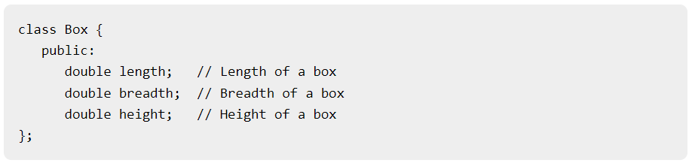

The keyword **public** determines the access attributes of the members of the class that follows it. A public member can be accessed from outside the class anywhere within the scope of the class object. You can also specify the members of a class as **private** or **protected** which we will discuss in a sub-section.

## Define Objects

A class provides the blueprints for objects, so basically an object is created from a class. We declare objects of a class with exactly the same sort of declaration that we declare variables of basic types. Following statements declare two objects of class Box-

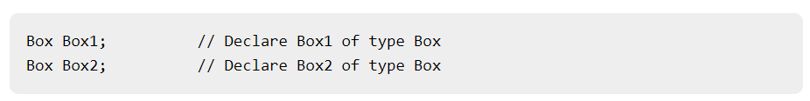

Both of the objects Box1 and Box2 will have their own copy of data members.

## Accessing the Data Members

The public data members of objects of a class can be accessed using the direct member access operator (.).Let us try the following example to make the things clear –

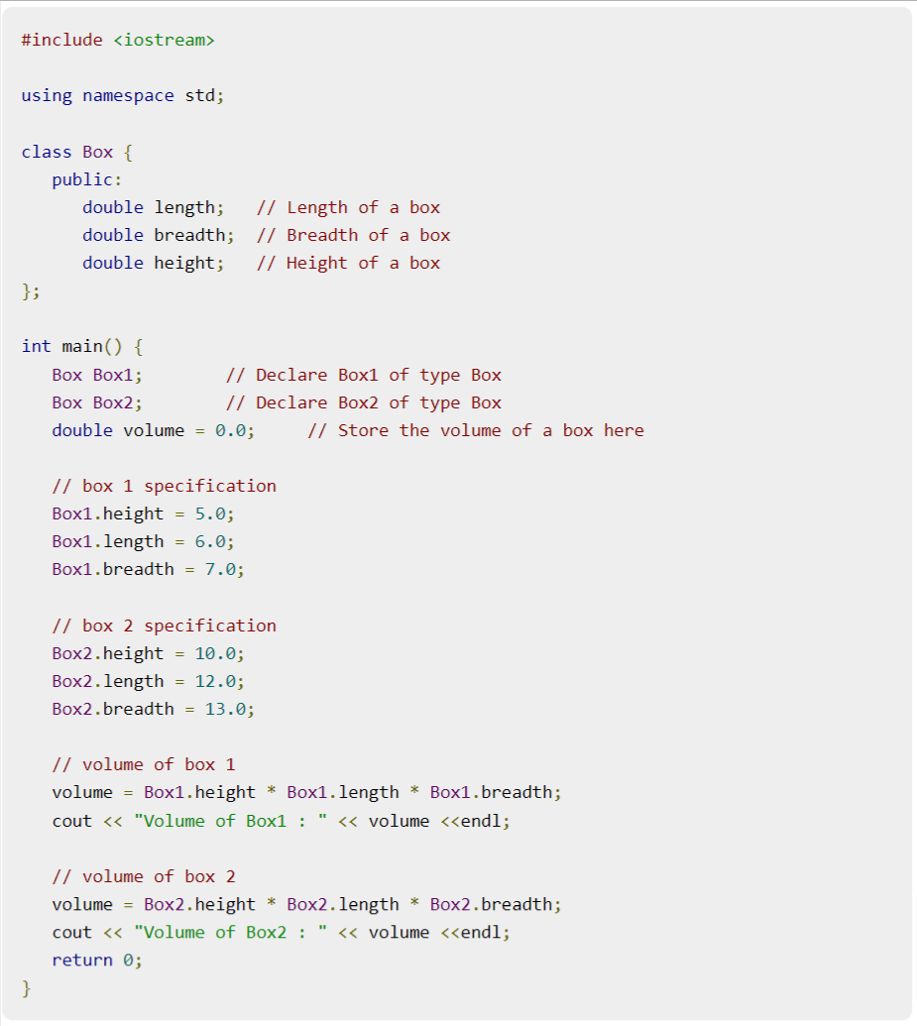

When the above code is compiled and executed, it produces the following result –

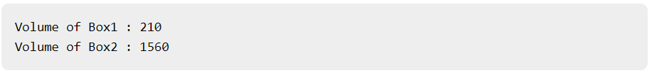

Thank you